**Advance Excel Assignment 5**

1. How many types of conditions are available in conditional formatting on Excel?

1. Color Scales change the color of each cell based on its value. Each color scale uses a two- or three-color gradient. For example, in the Green-Yellow-Red color scale, the highest values are green, the average values are yellow, and the lowest values are red.

1. Data Bars are horizontal bars added to each cell, much like a bar graph.
2. Icon Sets add a specific icon to each cell based on its value.

2. How to insert border in Excel with Format Cells dialog?

1. Click the down arrow next to the Borders button on home tab, and then click More Borders at the bottom of the drop-down list.

2. In the Format Cells dialog box, switch to the Border tab and choose the line style and color first. And then, either use Presets to add the outside or inside borders or construct the desired border by selecting individual elements such as border top, bottom, right or left. The preview diagram will reflect the changes immediately & then click ok.

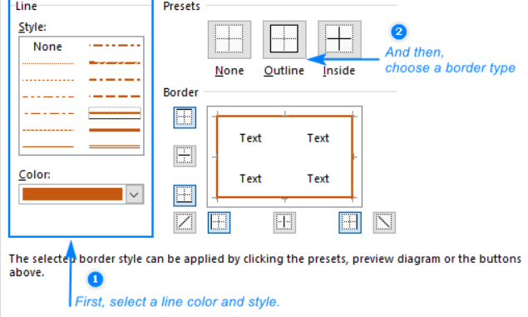

3. How to Format Numbers as Currency in Excel?

1. Select the cells that you want to format and then, in the Number group on the Home tab, click the down arrow in the Number Format box.
2. Choose either Currency or Accounting.

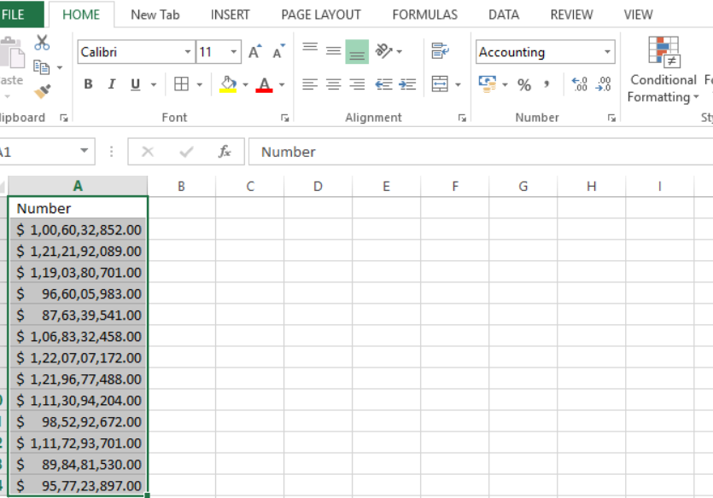

Currency

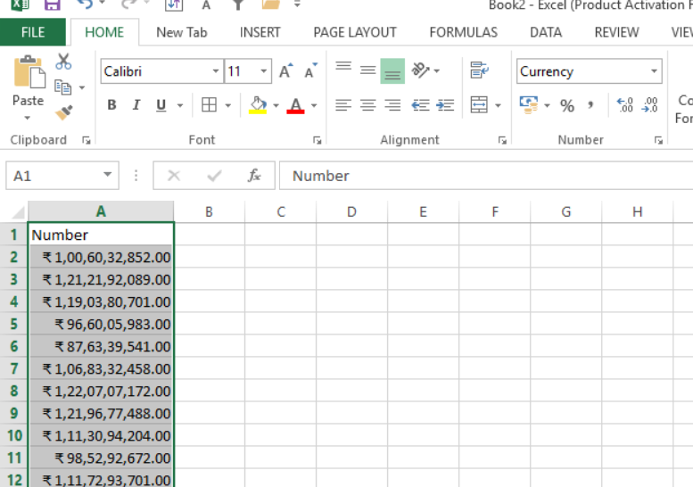

1. What are the steps to format numbers in Excel with the Percent style?

Select the cells for which formatting needs to be done, click Percent Style Button image in the Number group on the Home tab, or press Ctrl+Shift+%.

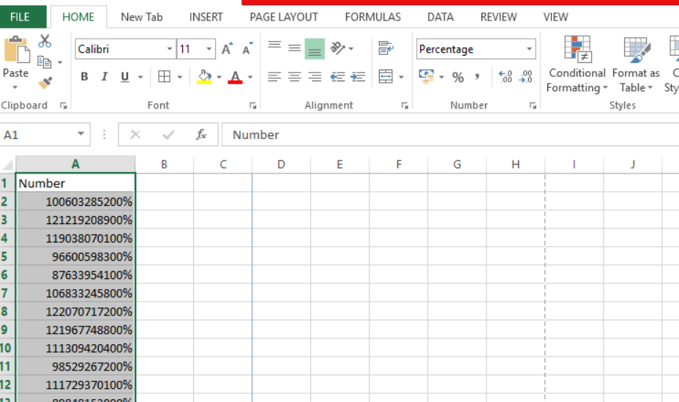

1. What is a shortcut to merge two or more cells in excel?

Alt + H + M + M

1. How do you use text commands in Excel?

Select the cells for which formatting needs to be done, click Text Button image in the Number group on the Home tab.

